**CIDM/ECON 6308 Exam 2 Part 2 Screenshot Submission**

**Due 11:59 CT August 16, 2018**

Your Name (First Last): Megan Moore Email Address: [mmmoore2@buffs.wtamu.edu](mailto:mmmoore2@buffs.wtamu.edu)

Attention: **Each screenshot must include date and time. Sharing your screenshots, or answers with other students is considered as cheating. Your score is purely based on your answers to each question, but failure to provide a reliable screenshot may receive a penalty of 50% points.**

Screenshot 1

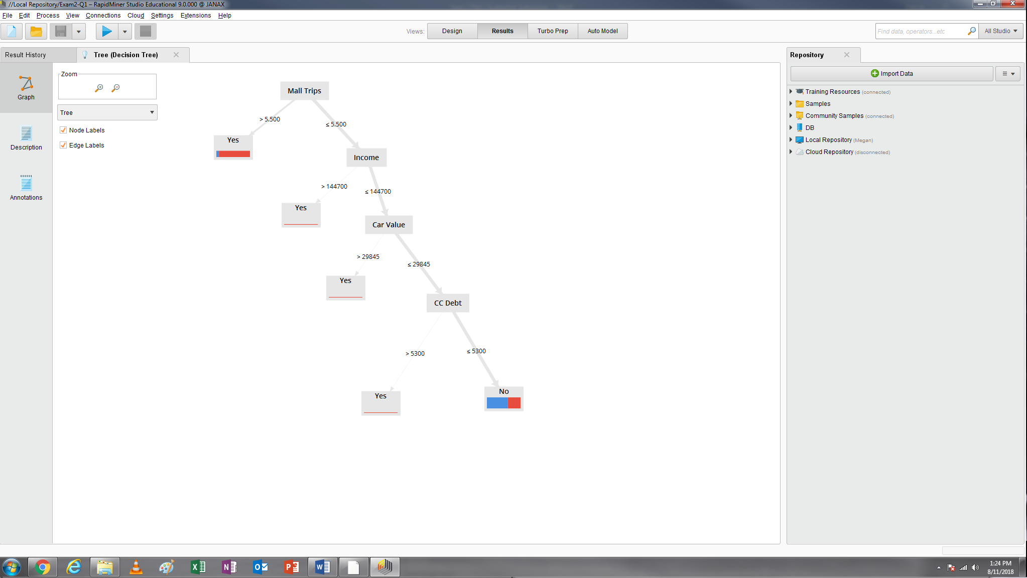

Question 1.3.1: In addition to the root node, how many other split nodes are included your decision tree? 3

Question 1.3.2: how many leaf nodes are a pure class (i.e., single color in the leaf node)? 3

Question 1.3.3: which attribute is located at your root node? Mall Trips

Step 1.4

|  |  |  |  |  |  |  |  |  |  |  |  |  |  |  |
| --- | --- | --- | --- | --- | --- | --- | --- | --- | --- | --- | --- | --- | --- | --- |
| ID | Age | Weight | Income | Pay Type | Car Value | | CC Debt | Gender | Live Alone | Dwell Type | Mall Trips | Nbhd | Will Try | |
| 1 | 58 | 173 | 73000 | Salaried | | 34520 | 950 | Female | Yes | Condo | 8 | East | Yes | |
| 2 | 34 | 182 | 66400 | Salaried | | 10130 | 4500 | Female | No | Condo | 1 | East | No | |
| 3 | 53 | 156 | 45500 | Hourly | | 2190 | 3510 | Male | No | Home | 5 | East | No | |
| 4 | 51 | 175 | 39100 | Hourly | | 22560 | 740 | Female | Yes | Condo | 7 | West | Yes | |
| 5 | 48 | 154 | 42200 | Salaried | | 5140 | 1910 | Male | No | Condo | 6 | West | Yes | |
| 6 | 56 | 244 | 19000 | Hourly | | 700 | 1620 | Female | No | Home | 2 | West | No | |
| 7 | 28 | 188 | 81400 | Salaried | | 26620 | 600 | Male | Yes | Apt | 5 | East | No | |
| 8 | 46 | 189 | 46200 | Salaried | | 10250 | 2860 | Male | Yes | Condo | 7 | East | Yes | |
| 9 | 35 | 200 | 61100 | Salaried | | 27210 | 3180 | Male | No | Condo | 15 | West | Yes | |
| 10 | 29 | 159 | 49800 | Salaried | | 20090 | 1270 | Female | Yes | Apt | 6 | West | | Yes |
| 11 | 40 | 165 | 120000 | Salaried | | 36480 | 1000 | Male | No | Home | 4 | West | | Yes |

Screenshot 2

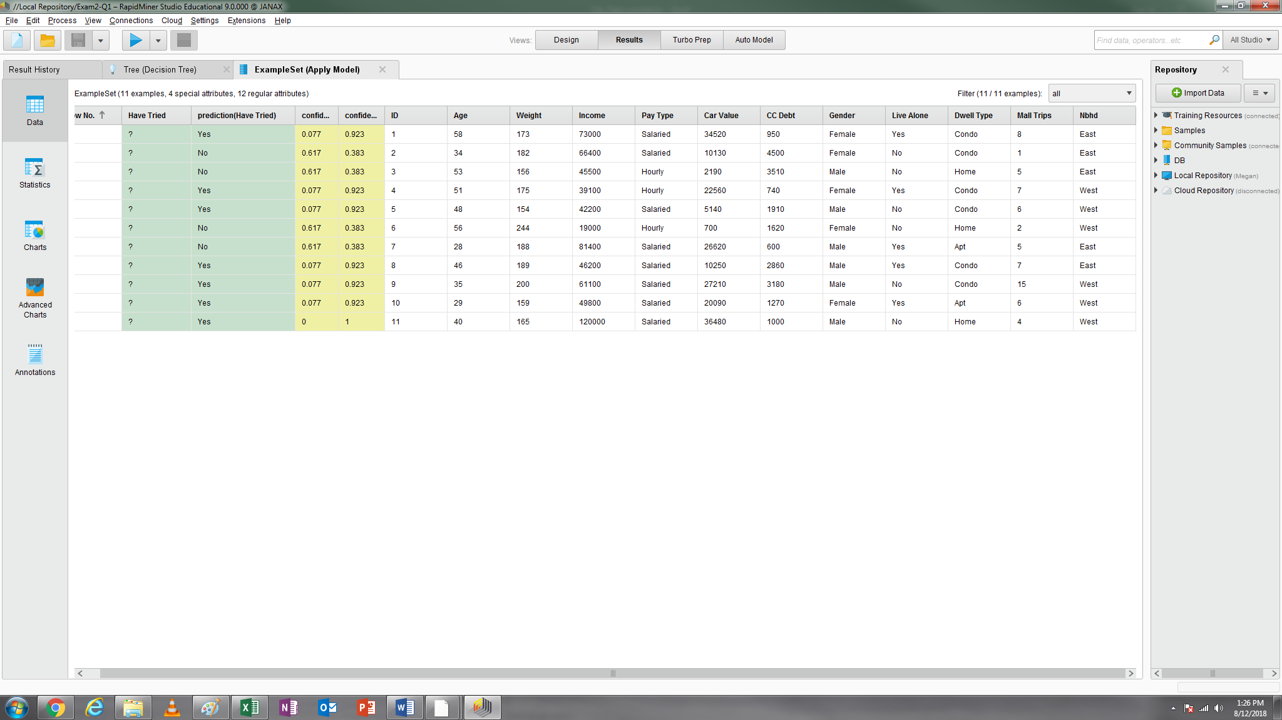

Question 2.1: Please indicate how many attributes are highly correlated (i.e., correlations greater than 0.85 or smaller than -0.85). (3 points) 0

Screenshot 3

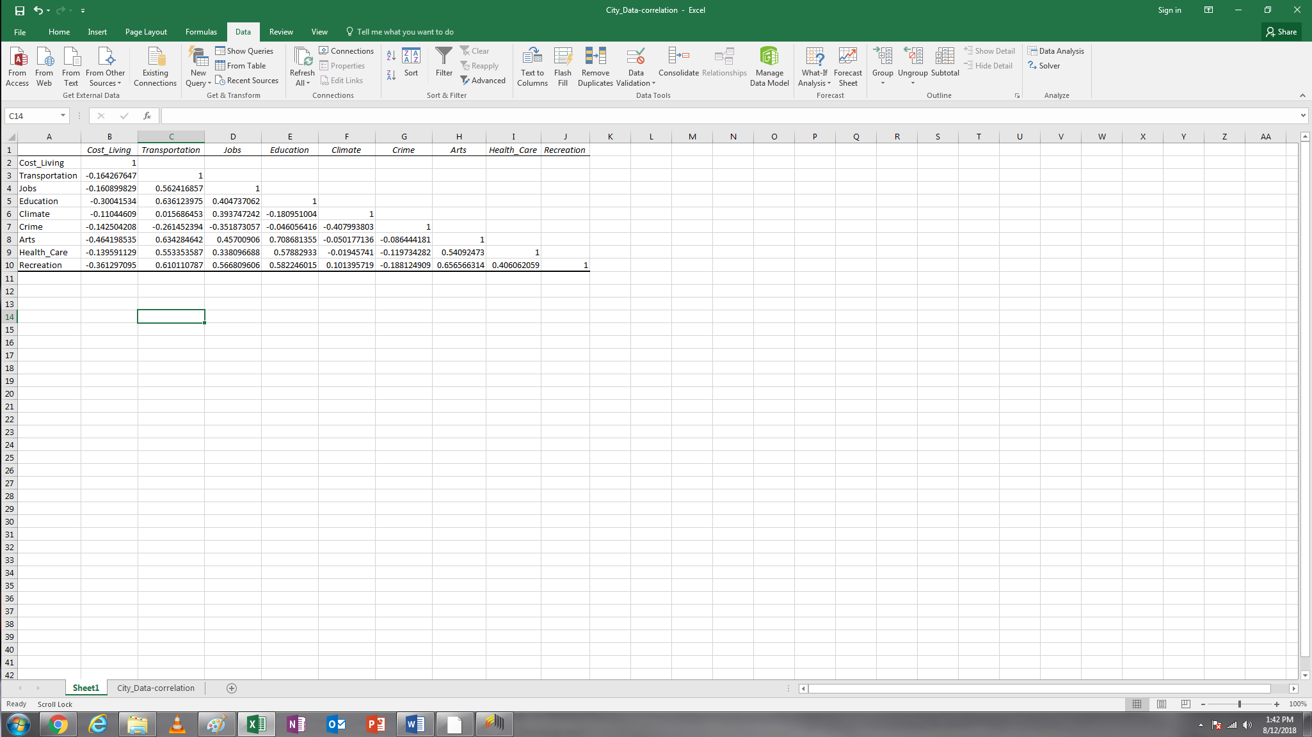

Screenshot 4 (shown below is K=10)

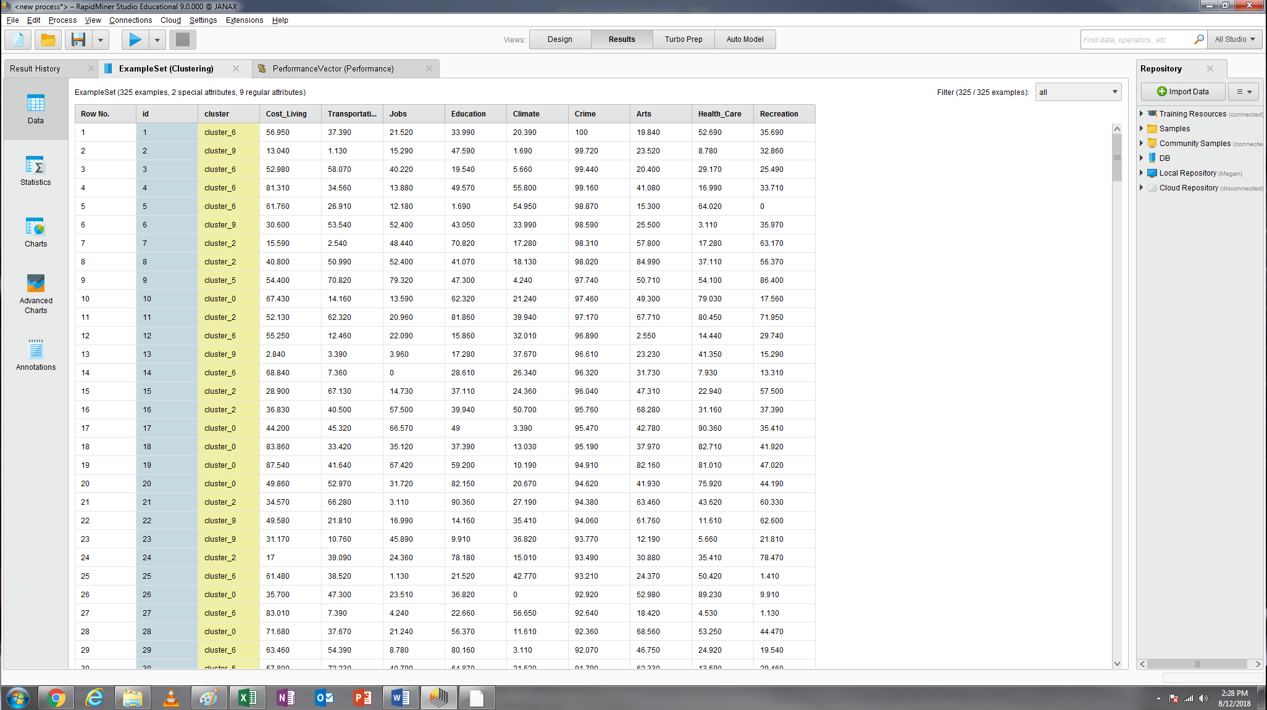

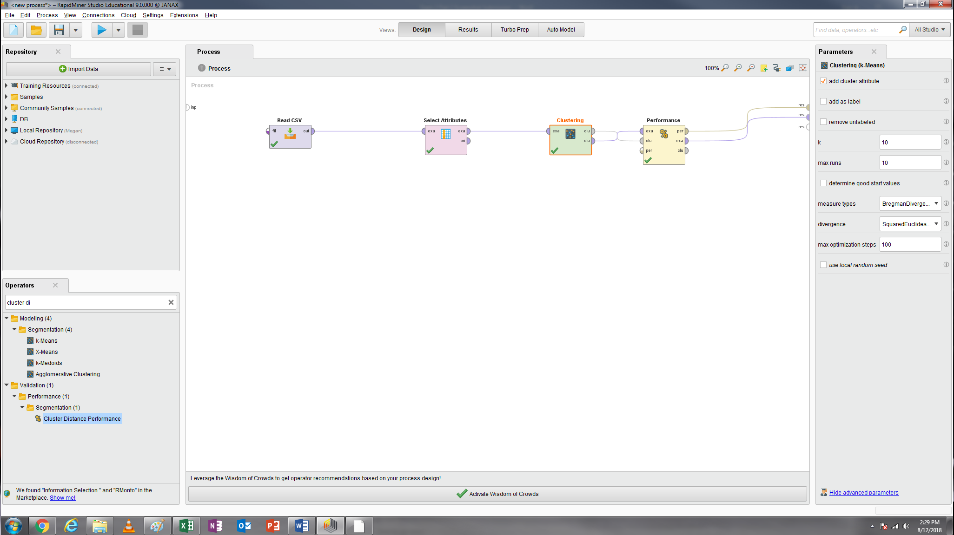

Question 2.2: Based on your analysis, please complete the following table (For Avg. within centroid distance and Davies Bouldin index, please round them to the second decimal place, e.g., -11.11). You may refer to Class 8 Lab for this question (24 points).

|  |  |  |  |  |  |
| --- | --- | --- | --- | --- | --- |
|  | Avg. within centroid distance | Davies Bouldin index | The smallest number of cities in one cluster | The largest number of cities in one cluster | Ratio |
| K=3 | -4360.06 | -1.70 | 100 | 116 | 1.16 |
| K=4 | -3916.48 | -1.73 | 72 | 87 | 1.21 |
| K=5 | -3598.60 | -1.67 | 54 | 81 | 1.50 |
| K=6 | -3416.38 | -1.68 | 35 | 77 | 2.20 |
| K=7 | -3185.46 | -1.65 | 28 | 63 | 2.25 |
| K=8 | -3033.73 | -1.60 | 28 | 53 | 1.89 |
| K=9 | -2912.01 | -1.65 | 26 | 58 | 2.23 |
| K=10 | -2790.65 | -1.71 | 25 | 45 (44?) | 1.76 |

Screenshot 5

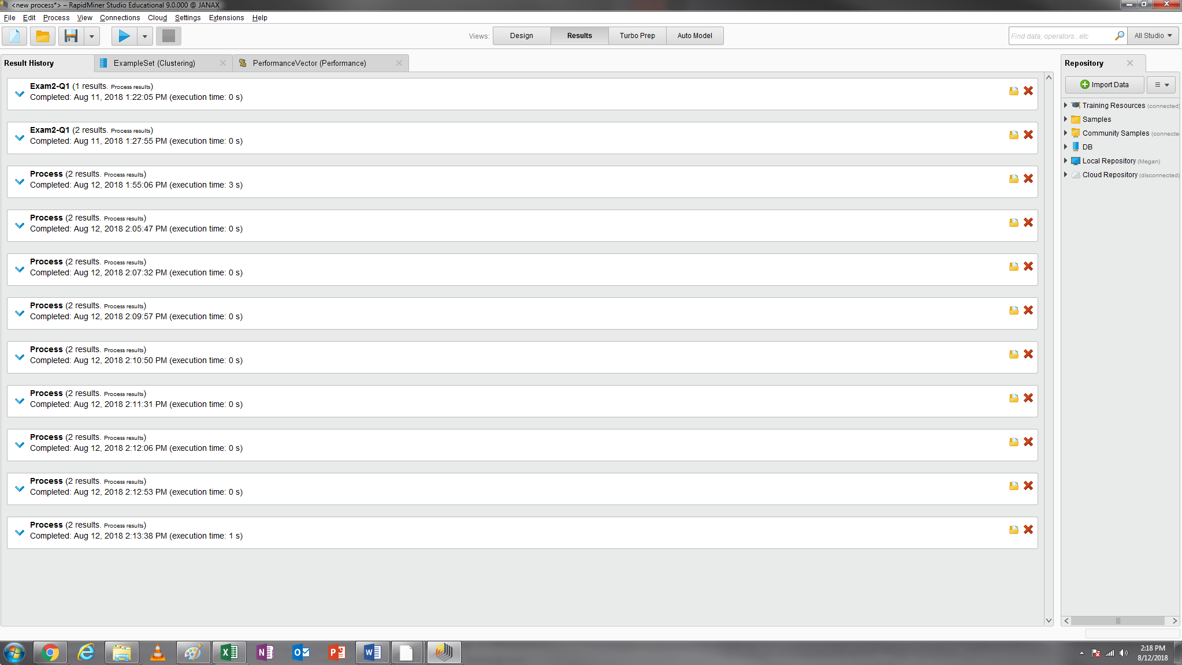

Question 2.3: Based on the evaluation method mentioned above, which model you are going to consider as the best one? K=? (3 points). 8